Buyer Name: DT Global Sudan TEPS | Ship To Name: DT Global Sudan TEPS | Vendor Name: | Business Size:
Telephone: +249 916677799  Email: procurements@aisudan.com  Location: 114 Block 21, Riyadh, P.O. Box 77052, 11123, Khartoum, Sudan | Attention: Procurement Department  Address: 114 Block 21, Riyadh  City/State/Zip: P.O. Box 77052, 11123 Khartoum, Sudan  Telephone: +249 916677799 | Attention:  Address:  City/State/Zip:  Telephone:  Fax:  Email:

Issue Date: | March 15, 2023 |  | Required Delivery Date |  | Commercial Item: | ☒ Yes | ☐ No
Quote Due Date: | March 23, 2023 |  | March 25, 2023 |  | Payment Terms: | Cheque after full delivery
Quote Valid Until: | March 23, 2023 |  |  |  | Freight on Board: DDP | ☐ Origin | ☒ Destination

Requirements:
EQUIP FOR FUTURE GENERATIONMAKERSPACE - (T-DAM068)

_________________________
Offeror’s Name, Title, Signature, Stamp (if available) Date

Instructions to Offerors:
- Submission Deadline: Final submissions will be due no later than, March 23, 2023 at 3:00 PM; 15:00 hours Sudan Time, submission to Almoana.mohamed@aisudan.com by email submission.
- Question & Answers: Questions regarding the RFQ No. TEPS-2022-011 shall be submitted to Almoana.mohamed@aisudan.com no later than March 23, 2023, 3:00 PM; 1500 hours (Sudan Time). Answers to questions will be distributed via email to all interested parties within 24-48 hours after the question deadline.
Please reference the RFQ number in any response to this RFQ. Offers received after this time and date will be considered late and will not be considered.

DT Global will not respond to questions pertaining to this RFQ over the phone. DT Global will not in any way assist Offerors in preparing their bids nor reimburse any bid preparation costs incurred by the Offeror.

Procurement Ethics
Neither payment nor preference shall be made by either the Offeror, or by any TEPS staff member, to affect the results of the award. TEPS treats all reports of possible fraud/abuse very seriously. Acts of fraud or corruption will not be tolerated, and TEPS employees and/or subcontractors/grantees/vendors who engage in such activities will face serious consequences. Any such practice constitutes an unethical, illegal, and corrupt practice and either the Offeror or the TEPS staff may report violations to the ethics and compliance anonymous via email to ethics@aisudan.com. TEPS ensures anonymity and an unbiased, serious review and treatment of the information provided. Such practice may result in the cancellation of the procurement and disqualification of the Offeror’s participation in this, and all future procurements. Violators will be reported to USAID, and as a result, may be reported to the relevant U.S. government agencies to be included in a Restricted Parties list, preventing them from participating in future U.S. Government business.

Mandatory Submission Requirements:
- Official quotation, including specifications of offered equipment (see illustrative specifications table for template)
- Valid copy of Business Registration Certificate or License
- NDAA Section 889 Representation Form. DT Global reserves the right to disqualify any offeror using covered materials. See Annex A.
- Consent to accept all USAID/DT Global policies & Declarations.

This request for quote does not constitute an order. Buyer will not pay offer preparation costs. Buyer may accept other than the lowest priced offer based on trade-offs between cost and quality or to further its socioeconomic programs. Buyer reserves the right to reject offers (a) received after the date and time specified, (b) not responsive to the solicitation, (c) with unbalanced line item pricing, or (d) from vendors restricted from doing business with the U.S. Government.
Notwithstanding the terms of this Request for Quote/Proposal, offeror acknowledges that DT Global reserves the right to reject any or all Quotes/Proposals for whatever reason DT Global determines, in its sole discretion, to be in its best interests. Offeror further acknowledges that DT Global may for whatever reason waive any or all formalities and terms of this Request for Quote/Proposal and that nothing in the terms of this Request for Quote/Proposal shall give rise to any claim or cause of action, including without limitation any claim for breach of implied-in-fact contract to treat Quotes/Proposals in accordance with the terms herein.
- Material Safety Data Sheets (MSDS) are required with quote.
- No substitutes or From Fit and Function alternative part numbers will be accepted.
- Product or Service is in support of a Government Contract.
- Shipping – Package items for shipment in accordance with the International Air Transport Association (IATA) regulations.
- Freight MUST be priced Separately
⁽¹⁾ Please provide the applicable U.S. Department of State International Traffic in Arms Regulations (ITAR) United States Munition List (USML) classification category or the U.S. Dept. of Commerce Export Administration Regulations (EAR).
⁽²⁾ Export Controls Classification (ECCN) for your product.
⁽³⁾ Additionally, please provide the National Stock Number (NSN) of the products requested, if applicable.
The following apply to this Request for Quote:
☐ DPAS Rated Order:
☐ Buy American Act
☐ Buy American—Free Trade Agreements—Israeli Trade Act
☐ Trade Agreements Act
☐ Preference for Certain Domestic Commodities—Berry Amendment
☐ Restriction on Acquisition of Hand or Measuring Tools—Berry Amendment ☐ Tax Exempt as provided
☐ Prime Contract Flow Downs as provided in Mandatory Flow Downs
Terms and Conditions:
☐ Terms and Conditions
☐ Terms and Conditions—Commercial
Representations and Certifications:
☐ Vendor Business Registration/Representations and Certifications—Non-Commercial
☐ Vendor Business Registration/Representations and Certifications—Commercial
☐ Indirect and Non-Government Vendor Business Registration
☐ Supplemental Certifications
Wage Determination:
☐ Service Contract Act as provided ☐ Davis Bacon Act as provided

Background:
DT Global is currently implementing the USAID-funded Toward Enduring Peace in Sudan (TEPS) project to support Sudan’s transition to an increasingly peaceful, democratic, and resilient country for all. In support of project implementation activities, TEPS requires the purchase and supply of school furniture (Student desk, Student seat, Teacher office table, Teacher office cupboard, Teacher office cupboard, Teacher office chairs, Blackboard)
Description of Scope:
The purpose of this Request for Quotations (RFQ) is to solicit quotations from eligible suppliers for these items, to be delivered within a 1-6 week(s) timeline to field sites in Sudan. TEPS anticipates issuing a fixed price Purchase Order (PO) for the commodity items listed in the specification requirements. DT Global reserves the right to award this subcontract to one or more subcontractors, or not award the subcontract at all. The subcontractor must possess all required business licenses, registrations, and documentation.

Source/Nationality/Manufacture:
All goods and services offered in response to this RFQ or supplied under any resulting award must meet USAID Geographic Code 937 in accordance with the United States Code of Federal Regulations (CFR), 22 CFR §228. The cooperating country for this RFQ is Sudan.

Offerors may not offer or supply any commodities or services that are manufactured or assembled in, shipped from, transported through, or otherwise involving any of the following prohibited countries: Cuba, Iran, North Korea, and Syria.

Evaluation and Award of Proposals:
The award will be made to a responsible offeror whose offer follows the RFQ instructions, meets the submission requirements, and meets or exceeds the minimum required technical specifications. This procurement will be evaluated based on a lowest-price, technically acceptable basis. The relative importance of each individual criterion is indicated by the number of points below:
- Technical Responsiveness to the technical specifications and requirements.
- Experience & Knowledge: proven experience and knowledge of similar projects (certificates)
- Delivery: The speed of delivery.
- Warranty/After-Sales Service –: Length of warranty and after sale services.

Specifications Requirements:
The table below contains illustrative specification requirements of the commodities/services. Offerors are requested to provide quotations containing the information below on official letterhead or official quotation format. In the event this is not possible, offerors may complete this table and submit a signed/stamped version to TEPS.
Table (1)
No. | Item | Description/Condition | QTY | Unit Price (SDG) | Total Amount (SDG)
1 | Machine | ANNOYTOOLS CNC Router Machine All Metal 3018 PRO+ with 500W spindle, Limit Switches & Emergency Stop,300x180x60mm Working Area CNC Machine for Wood, Acrylic, Aluminum Carving | 1
 |  | 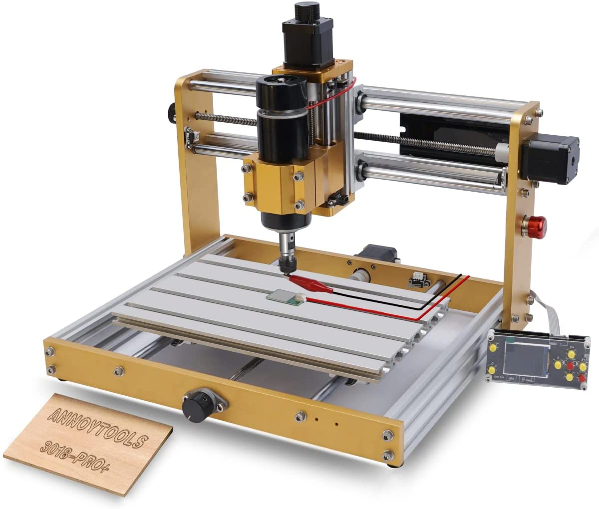
 |  |  |  | Grand Total

Terms & Conditions
- Delivery time (after receipt of order): ________calendar days
- Length of warranty on offered equipment: Months/Years.
- Location of service center(s) for after-sales service, including warranty repair (if any): ______________
- Payment terms:
- Retention terms:
- Insurance coverage to all activities:
- Quality of items provided according to:
- DT Global will provide exemptions

Award of Contract:
- DT Global avail itself the right to add/deduct 30% of the RFQ scope of the work.
- Clear Installation plan for all sites.
- Pre-shipment inspection certificate shall be issued at the cost of the selected supplier and provided to DT Global before the consignment is dispatched from the supplier’s warehouse. To confirm specifications and rules of Nationality.
- Upon supplier’s acceptance of and signature of DT Global contract/PO for goods, after accepting DT Global General Terms and Conditions, and upon Submission of Performance Guarantee Certificate contractor will be obliged to all conditions including risk mitigation majors and liquidating of damage.
- Partial bids per LOT is accepted, nevertheless partial activity (supply, Transportation, clearance, Installations, Warranty) is not accepted.
Delivery Instructions:

Delivery Term  [INCOTERMS 2010]  (Pls. link this to price schedule) | DDP to destinations specified in address below
Exact Address of Delivery/Installation Location | DT Global Khartoum Office
Mode of Transport Preferred | Up to the contractor to decide so long as delivery date is met
Delivery Date | 5 days after signing PO
Customs, if needed, clearing shall be done by: | ☒ Supplier
Inspection upon delivery | ☒ DT Global shall inspect the equipment on receipt at destination.  ☒ If the equipment fails to meet the contract specifications, the Supplier shall take immediate steps to remedy the deficiency or replace the entire defective equipment at their own cost to the specified specification.
Installation Requirements | ☒
Technical Support Requirements | Yes, by supplier
Packing and Labeling Requirements | Important Good packaging water proof and dust proof cartons & Solofan
Conditions for Release of Payment | ☒ Written Acceptance of Goods based on full compliance with RFQ requirements
All documentations, including catalogs, instructions and operating manuals, shall be in this language | ☒ English

ANNEX 1
REPRESENTATION REGARDING CERTAIN TELECOMMUNICATIONS AND VIDEO SURVEILLANCE SERVICES OR EQUIPMENT
(a) Prohibitions.
Section 889(a) of the John S. McCain National Defense Authorization Act for Fiscal Year 2019 (Pub. L. 115-232) prohibits the U.S. Government and any of its contractors and subcontractors from procuring or obtaining, or extending or renewing a contract to procure or obtain, any equipment, system, or service that uses covered telecommunications equipment or services as a substantial or essential component of any system, or as critical technology as part of any system.
(b) Definitions:
Covered foreign country means The People’s Republic of China.
Covered telecommunications equipment or services means telecommunications equipment produced by Huawei Technologies Company, ZTE Corporation, Hytera Communications Corporation, Hangzhou Hikvision Digital Technology Company, or Dahua Technology Company (or any subsidiary or affiliate of such entities)
Critical technology means defense articles or defense services included on the United States Munitions List set forth in the International Traffic in Arms Regulations under subchapter M of chapter I of title 22, Code of Federal Regulations; Items included on the Commerce Control List set forth in Supplement No. 1 to part 774 of the Export Administration Regulations under subchapter C of chapter VII of title 15, Code of Federal Regulations, and controlled- (i) Pursuant to multilateral regimes, including for reasons relating to national security, chemical and biological weapons proliferation, nuclear nonproliferation, or missile technology; or (ii) For reasons relating to regional stability or surreptitious listening; Specially designed and prepared nuclear equipment, parts and components, materials, software, and technology covered by part 810 of title 10, Code of Federal Regulations (relating to assistance to foreign atomic energy activities); Nuclear facilities, equipment, and material covered by part 110 of title 10, Code of Federal Regulations (relating to export and import of nuclear equipment and material); Select agents and toxins covered by part 331 of title 7, Code of Federal Regulations, part 121 of title 9 of such Code, or part 73 of title 42 of such Code; or Emerging and foundational technologies controlled pursuant to section 1758 of the Export Control Reform Act of 2018 (50 U.S.C. 4817).
Reasonable inquiry means an inquiry designed to uncover any information in the entity's possession about the identity of the producer or provider of covered telecommunications equipment or services used by the entity that excludes the need to include an internal or third-party audit.
Substantial or essential component means any component necessary for the proper function or performance of a piece of equipment, system, or service.
(c) Representation. After conducting a reasonable inquiry Subcontractor represents that it [ ] will or [ ] will not provide covered telecommunications equipment or services to DT Global in the performance of any contract, subcontract, order, or other contractual instrument resulting from this contract. This representation shall be provided as part of the proposal and resubmitted on an annual basis from the date of award.
(d) Disclosures. If the Subcontractor has responded affirmatively to the representation in paragraph (c) of this clause, the Subcontractor shall provide the following additional information to DT Global:
(1) List of all covered telecommunications equipment and services offered or provided (Entity name, brand; model number, such as original equipment manufacturer (OEM) number, manufacturer part number, or wholesaler number; and item description, as applicable);
(2) Explanation of the proposed use of covered telecommunications equipment and services and any factors relevant to determining if such use would be permissible under the prohibition in paragraph (b) of this provision;
(e) Reporting requirement.
(1) In the event the Subcontractor identifies covered telecommunications equipment or services used as a substantial or essential component of any system, or as critical technology as part of any system, during contract performance, or the Subcontractor is notified of such by a subcontractor at any tier or by any other source, the Subcontractor shall report the information in paragraph (d)(2) of this clause to DT Global.
(2) The Subcontractor shall report the following information pursuant to paragraph (d)(1) of this clause
(i) Immediately upon such identification or notification: the contract number; the order number(s), if applicable; supplier name; supplier unique entity identifier (if known); supplier Commercial and Government Entity (CAGE) code (if known); brand; model number (original equipment manufacturer number, manufacturer part number, or wholesaler number); item description; and any readily available information about mitigation actions undertaken or recommended.
(ii) Within 5 business days of submitting the information in paragraph (d)(2)(i) of this clause: any further available information about mitigation actions undertaken or recommended. In addition, the Subcontractor shall describe the efforts it undertook to prevent use or submission of covered telecommunications equipment or services, and any additional efforts that will be incorporated to prevent future use or submission of covered telecommunications equipment or services.
(f) 2nd Tier Subcontracts. The Subcontractor shall insert the substance of this clause, including this paragraph (f), in all 2nd Tier subcontracts and other contractual instruments, including subcontracts for the acquisition of commercial items.
(g) SAM Verification. The Subcontractor shall regularly review the list of excluded parties in the System for Award Management (SAM) (https://www.sam.gov) to identify entities excluded from receiving federal awards for “covered telecommunications equipment or services”.
Signature: _____________________________
Date: _________________________________
Name: ________________________________
Title/Position: __________________________
Organization: ___________________________

Executive Compensation Certifications (FAR 52.204-10)
In accordance with Public Law 109-282 and FAR 52.204·10, Reporting Executive Compensation for First-Tier Subcontract Awards (JUL 2020), you are required to provide certain information pertaining to compensation of executives in order to be eligible for this subcontract award. Please answer the following question(s) in connection with this requirement:
- Did your organization in the previous tax year have gross income from all sources over USD 300,000?
Yes ☐ No ☐

If you answered “No” to question 1 above, you are exempt from this reporting requirement. Please sign in the spaces indicated below and return this certification to your point of contact at DT Globa. If you answered “Yes,” please complete Table I and answer the following questions:
- Did your company receive 80% or more of its annual gross revenues from Federal contracts (and subcontracts), loans, grants (and subgrants), and cooperative agreements in the preceding fiscal year?
Yes ☐ No ☐

- Did your company receive $25,000,000 or more in annual gross revenues from Federal contracts (and subcontract), loans, grants (and subgrants), and cooperative agreements in the preceding fiscal year?
Yes ☐ No ☐

- Does the public NOT have access to information about the compensation of your company's executives through periodic reports filed under 13(a) or l5(d) of the Securities Exchange Act of 1934 (15 U.S.C. 78m(a), 78o(d)) or section 6104 of the Internal Revenue Code of 1986? (To determine if the public has access to the compensation information, see the U.S. Security and Exchange Commission total compensation filing at http://www.sec.gov/answers/execomp.htm.)
Yes ☐ No ☐

If the answers to questions 2, 3 and 4 are all “Yes,” you are required to provide the names and total compensation of each of the five most highly compensated executives in your organization as part of this certification, and on an annual basis for the life of this subcontract. Provide this compensation information in Table II below. Please note that as required by public law and FAR 52.204-10(b), APL will report this information to the government, and this information will be made public. Further, please note your continuing obligation to immediately notify APL in writing of any changes to previously reported data.
This certification concerns a matter within the jurisdiction of an agency of the United States and the making of a false, fictitious, or fraudulent certification may render the maker subject to prosecution under Section 1001, Title 18, United States Code.
Company
Signature
Printed Name
Title
Date

Executive Compensation Certification (FAR 52.204-10)

Table I
Subcontractor DUNS Number
Subcontractor Parent Company DUNS Number (if applicable)
Subcontractor Primary Address
Must Include nine-digit zip code and Congressional district
Primary Location for Performance of Subcontract (if different from Primary Address)
Must Include nine-digit zip code and Congressional District
North American Industry Classification System (NAICS) code

Table II
 | Name | Total Compensation (as defined in FAR 52.204-10(a))
Executive 1
Executive 2
Executive 3
Executive 4
Executive 5

Table Ill (For Internal Use Only)
Subcontract number
Amount of the subcontract award
Date of the subcontract award
A description of the products or services being provided, including overall purpose, and expected results
The prime contract number
Awarding agency name and code
Funding agency name and code
Government contracting office code
Treasury Account Symbol (TAS)

